I would like to create a program (app) that takes a 2D photo and converts it to a semi abstract “painting”. I want to do this using 3d. I am hoping to do something a little different.
The goal is a painting that looks a bit like these..
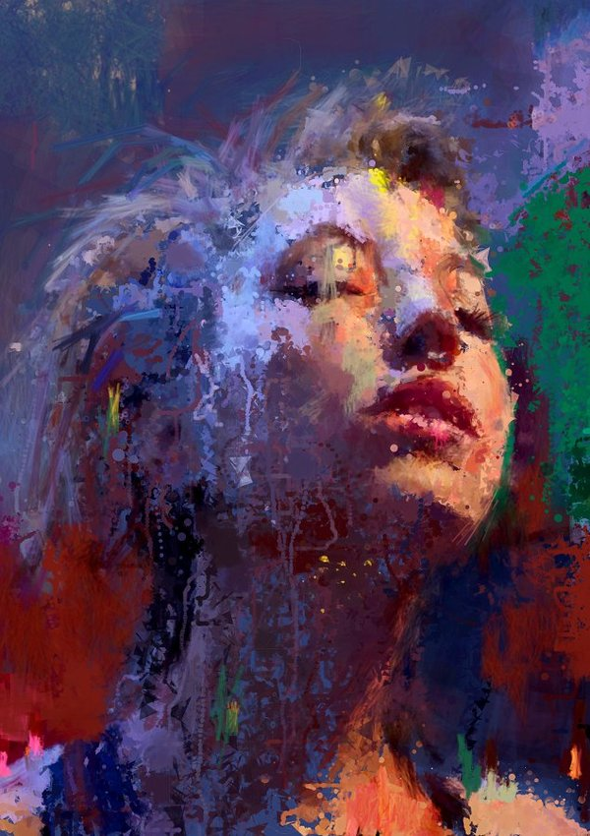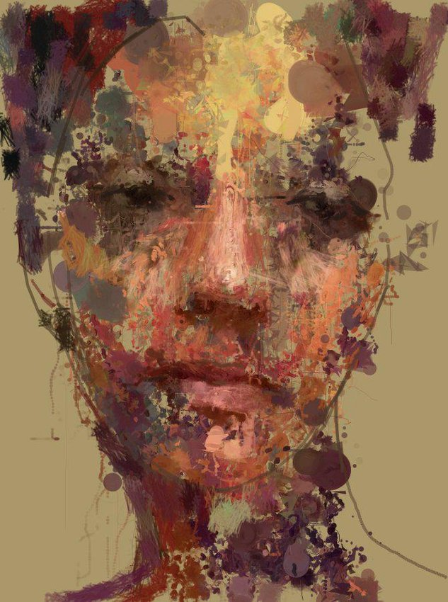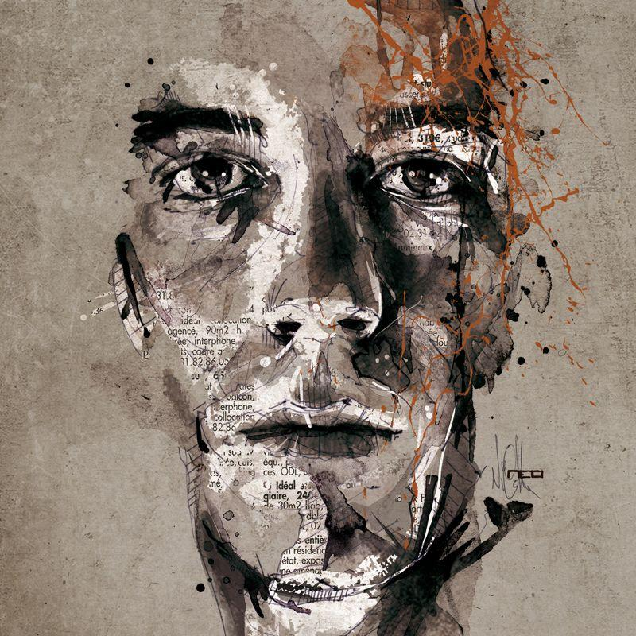

They appear chaotic at the level of individual brushstrokes, but remarkably organized at the level of the entire image.
I want to use some sort of procedural generation. I would build a system that understands the underlying 3D object, then uses that information to distribute thousands of marks—palette-knife strokes, scratches, translucent washes, splatters, and patches of colour—across its surface. During the procedure i will want some on hands input, control of parameters, both in 3d and 2D
The important distinction is that the randomness should affect how the object is painted, not whether the object remains recognizable.

I see six distinct visual mechanisms in these examples.
- Large colour masses. The face is established by relatively broad regions of light, dark, warm and cool colours. These carry much of the three-dimensional information.
- Palette-knife marks. Irregular, often angular patches of nearly uniform colour, with scraped or ragged edges.
- Directional brushwork. Marks tend to follow the structure of the face or hair, rather than being uniformly random.
- Splatters and tiny fragments. Hundreds or thousands of small, high-contrast marks produce surface complexity.
- Transparent layering. Earlier marks remain partly visible through later ones. Some areas look scraped away.
- Selective destruction. Large sections of the image are obscured or broken up, but the eyes, nose, mouth and main contours provide enough information for the brain to reconstruct the face.
You can obscure an enormous amount of an object and still recognize it, provided you preserve the right information.

The architecture

I will separate the system into two parts:
- a 3D information generator
- a procedural painter.

For a first version, I would not paint directly onto the 3D mesh. (Implying that in a second version i will hope to get procedural painting on the 3d mesh or meshes). I would render the model into several 2D images containing information about its shape, and use those images to drive a procedural painting algorithm.
That makes the problem much easier to develop and debug. Once it works, transfer the techniques back onto the 3D surface.
This is a tad like what i did in PostContemp. I used a bunch of particles run around a canvas like cars, picking up color from somewhere and placing it down along their path. The particles controlled a brush. They where guided at times by other bit maps, are a list vertices or some other underlying control structure.

Stage 1 — Extract information about the 3D object
Render the object into separate information maps:
- Normal map
- Depth map
- Lighting map
- Curvature map
These maps provide the intelligence behind the randomness. I assume that there are some public domain bits of software that create each of these maps. The fact that all the pictures are faces should mean there 2D MORPHABLE MODEL that is trained on a data set like FFHQ - Googles MediaPipe Face Mesh??

Stage 2 — Establish the painting's large colour regions
This is very much what the testing in Blobs was all about

Stage 3 — Create palette-knife strokes
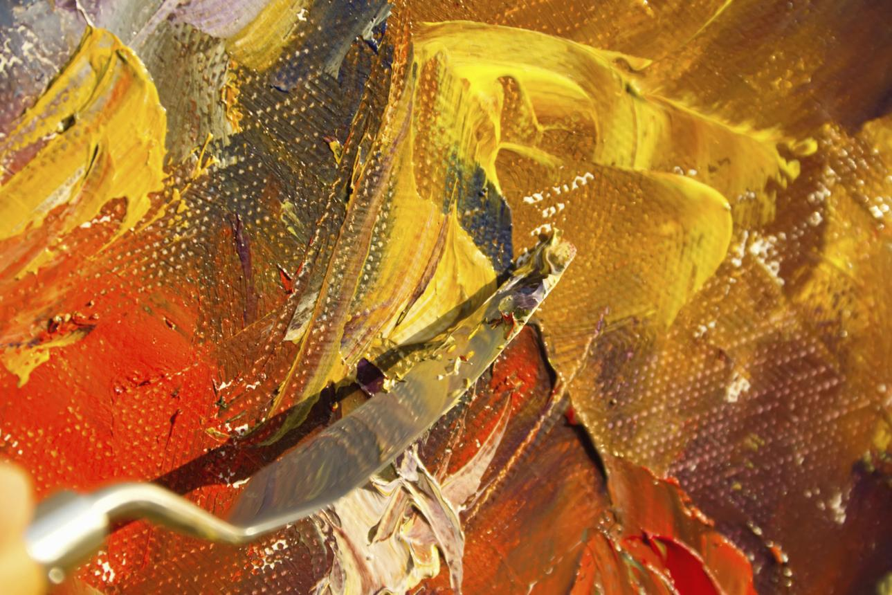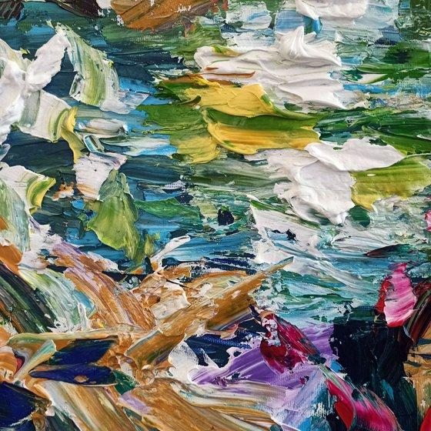
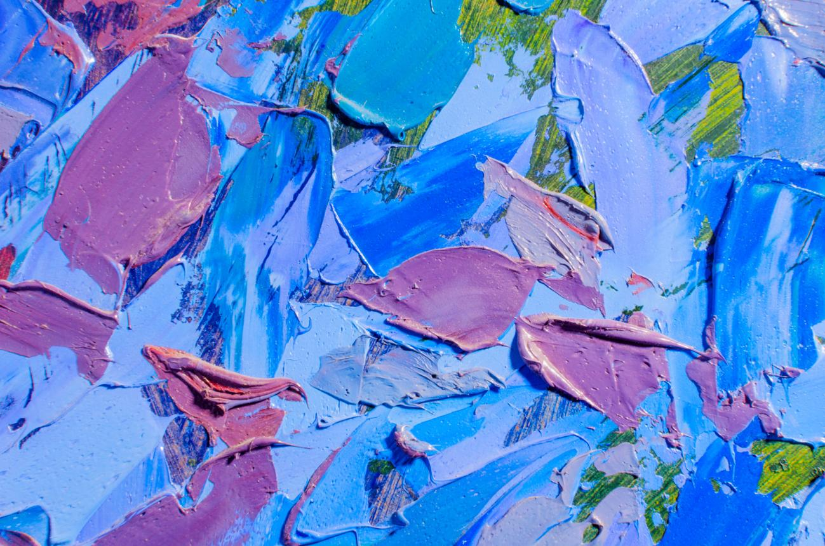

I would represent each palette-knife mark as an irregular polygon, not a conventional brush.

This will need a lot of experimenting…. Not sure how to do this yet.
Each mark has:
- Position and orientation
- Length and width
- An irregular outline
- A main colour and secondary colour
- Opacity
- An internal texture
- A probability of being partially scraped away
For example, a stroke could start as an elongated quadrilateral with 8–15 vertices. Perturb those vertices using correlated noise, then fill the shape with uneven colour.
The trick is to avoid independently randomizing every vertex using smooth noise combined with a few sharp discontinuities.

Stage 4 — Directional marks that follow the surface
The 3D model info runs the show here
Consider a curved surface, such as a cheek. Brushstrokes should have some tendency to follow the cheek's curvature.
Create a 2D direction field from the model's normals, projected geometry and feature boundaries.
For each brushstroke:
position = choose_surface_point()
direction = surface_direction(position)

direction += random_angle(-25, 25)

length = random_range(5, 45)
width = random_range(1, 12)

paint_stroke(position, direction, length, width)
Need a parameter called structure_following.
At 100%, every mark follows the object's geometry. At 0%, every mark is randomly oriented.
I suspect values around 40–70% would produce interesting results.
The idea is to appear as if strokes where created by someone who understands the form but isn't slavishly following it.

Stage 5 — Splatters, scratches and fine lines
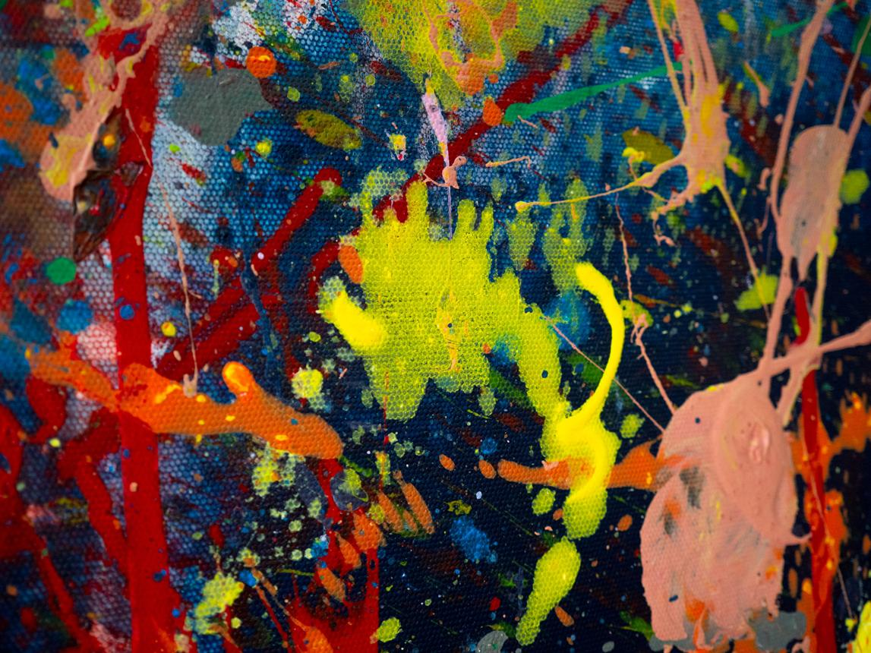
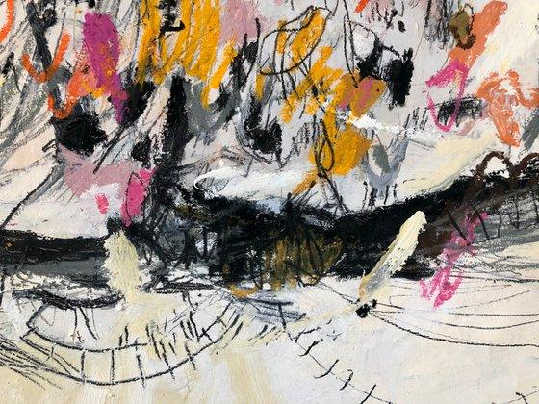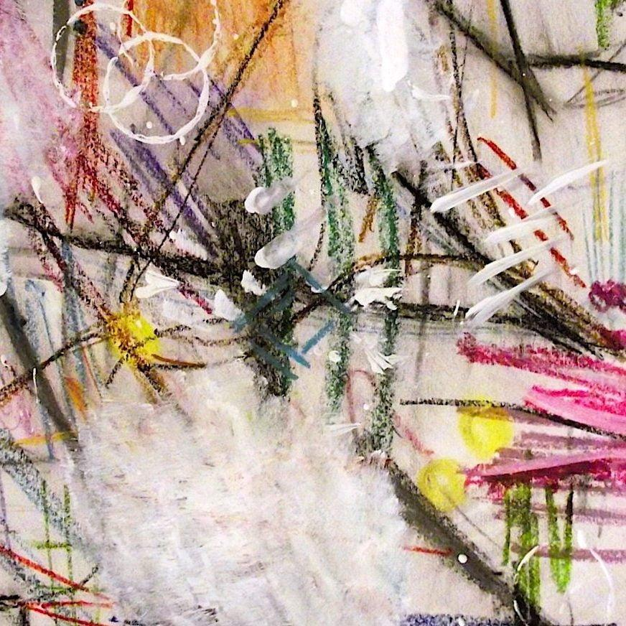

Separate mark-generating systems ??? with ndependent controls for density, size, colour variation and opacity.

Splatters: Use clustered distributions rather than uniform randomness. Choose a centre, then generate a variable number of droplets with positions following a Gaussian distribution. Use a heavy-tailed distribution for droplet sizes so that most are tiny but a few are conspicuously large.

Scratches: Generate short connected paths that reveal an earlier colour layer. Their direction can be partly random, partly influenced by the geometry.
Fine lines: Generate wandering Bézier curves or correlated random walks. Allow some lines to follow contours and others to ignore them.
Fragments: Add tiny polygons, dashes, dots, triangles and broken shapes.

Stage 6 — Controlled destruction
Rather than trying to place every mark correctly, start with an image that defines the object quite clearly and progressively destroy parts of it.
need to control where that destruction occurs.
calculate a map representing how important each part of the image is to recognizing the object.
For a face, the eyes, nostrils, lips and some silhouette boundaries would receive relatively high importance. Cheeks, forehead and hair could tolerate much greater disruption.
Need a parameter called abstraction.
Abstraction level
55%
Representational
Fragmented
High abstraction: Large sections are obscured. A few recognizable features anchor the image.
Importantly, I would preserve a small number of structural anchors even at high abstraction.

Notes from the reference images
(Added by Claude, 21 Oct 2026, after looking at the images in this document.)

What the face examples have in common
Detail and contrast concentrate in a triangle of eyes, nose and mouth, and the importance map falls off quickly outside it. In the blue/violet and khaki examples the background colour pushes right into the face, so the silhouette is only partly kept. The importance map should allow silhouette edges to be lost, not just protected.

Palette-knife marks (Stage 3)
The close-ups show flat, mostly single-colour patches with one hard, ridged edge and one feathered or torn edge, a secondary colour dragged along inside the stroke, and earlier layers or canvas weave showing through gaps. Shapes are more often leaf- or shard-like (blunt start, tapered or ragged end) than rectangular. Adding a thin highlight or shadow along the ridge edge would fake paint thickness.

Splatters and lines (Stage 5)
The splatter example has big blobs with smaller satellite droplets, long thin flung trails, and some semi-opaque splats with the canvas texture showing through. The crayon/pastel examples show scrubbed hatching, crossed lines, loose loops and grainy dry-media texture, which is a different family from the wet knife strokes.

Additions to the design
Ground / substrate layer. A paper, canvas-weave or text-collage layer (as in the ink face with newspaper text) that shows through gaps, translucent marks and scraped areas.
Accent colour. One saturated colour used sparingly, like the rust splatter on the monochrome ink face. It needs its own controls for hue, amount and placement.
Dry media. Crayon or pastel scribble as a separate mark type: thin, broken, grainy hatching and loops, distinct from the fine Bézier lines.
Fling trails. Splatter clusters can throw long, thin directional trails out from the cluster centre, tapering as they go.
Impasto relief. Give each mark a height map (ridge along the knife edge, thinning at the feathered end). In 2D it can drive fake lighting; in Version 3 it could displace the mesh.

The 3D examples and the closing question
The last two images, a figure whose strokes wrap around the form and a head sculpted out of thick impasto, are both painted 3D objects you could walk around rather than 2D paintings made from 3D. That points towards eventually doing Version 3 (object-space painting), possibly with strokes that displace the mesh as in the sculpted head.

Code Structure
Needs thought - depends on existing tools, access to web pages, manuel controls required…

6. Which programming environment?
Blender?? I have almost no experience but…. Live and learn
Photoshop - limited use….it is slow but i own it and kown it

Processsing - Java - I know it but
Python might be better! But i would need to learn it…. But it is probably better for painting

The distinction between painting an image and texturing a 3D object
There is one important architectural decision.
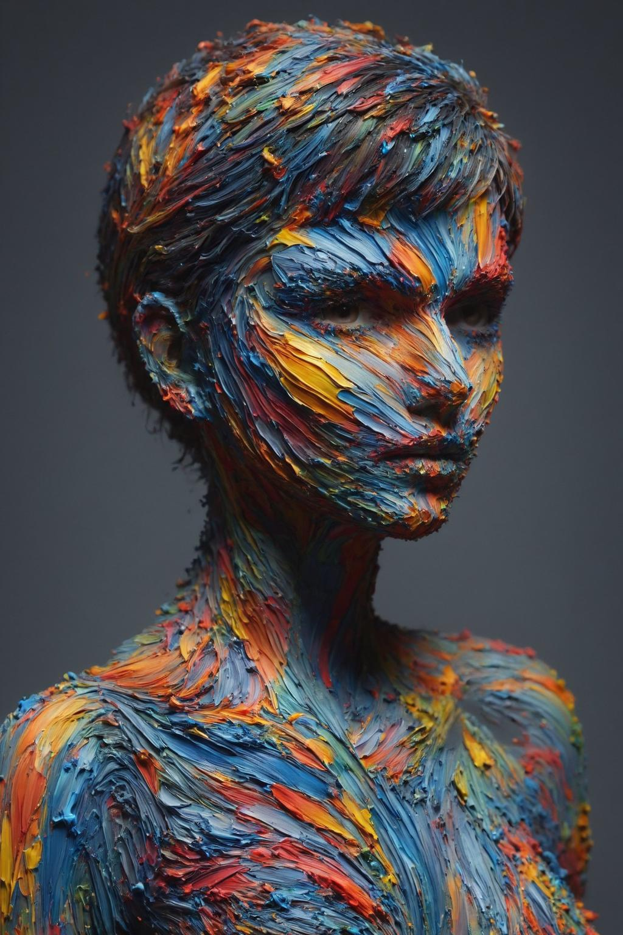
Screen-space painting
We paint the rendered image. This gives us maximum control over composition and brushwork, but the marks must be regenerated when the camera moves.
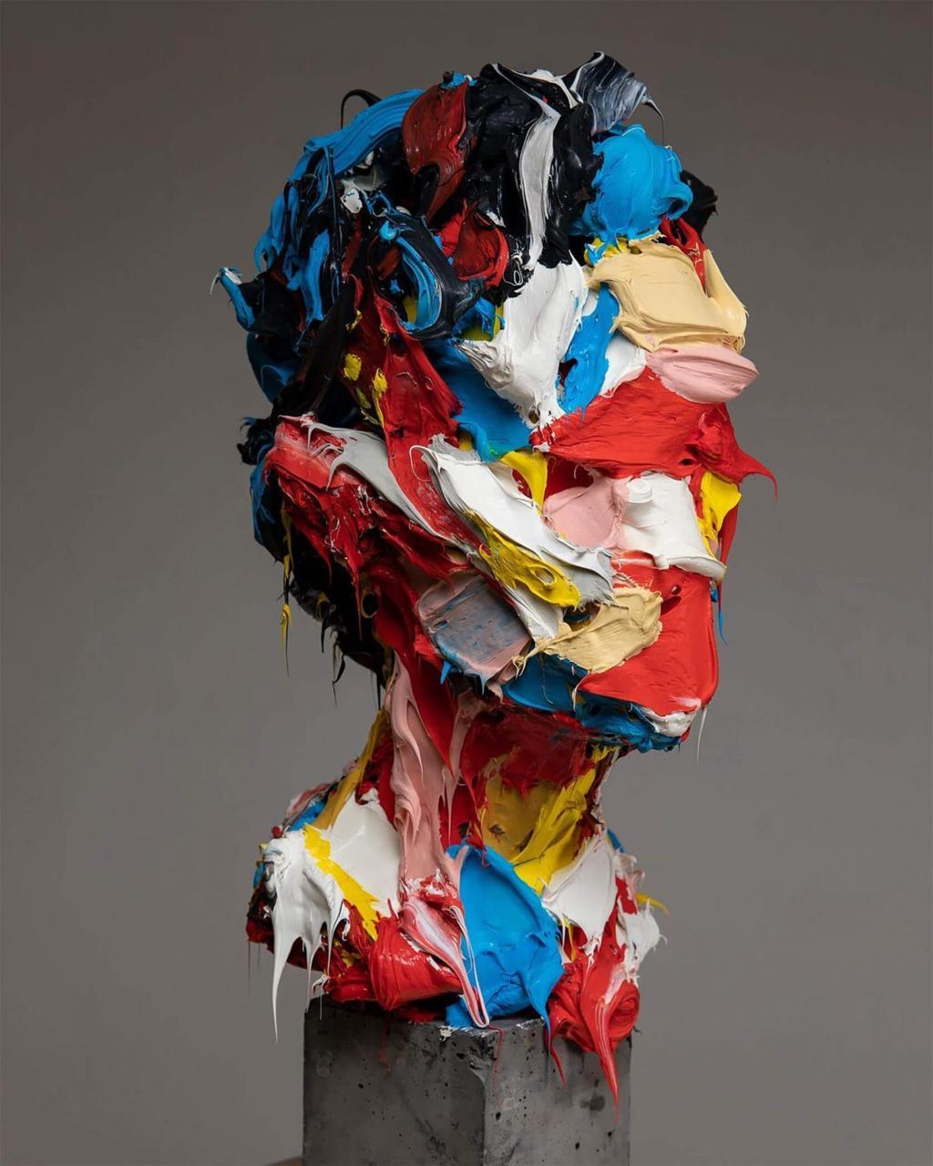
Object-space painting
We paint into the object's UV texture or place marks on its surface. The marks remain attached to the model when it rotates.
For a genuinely textured 3D object, I would eventually generate marks in UV space, using the mesh's surface normals and curvature to influence their orientation and distribution. We would need to handle UV seams and overlapping surfaces carefully.
There is also a hybrid approach: create most marks on the 3D surface, then add a second screen-space layer of splatters and scratches. That may come closest to your examples, because some marks appear to define the face while others seem to float independently of it.

Version 1 — The mark-making engine. Start with a photograph or rendered image and implement palette-knife strokes, splatters, scratches and irregular colour patches. We could quickly test which combinations produce the desired aesthetic.
Version 2 — Geometry-aware painting. Use normals, depth and feature information from a 3D model to guide the marks. Add controlled abstraction and selective preservation of recognizable features.
Version 3 — True 3D texturing. Transfer the mark-generation process onto the mesh itself, so that the object can rotate and be viewed from different angles while retaining its painted surface.
I think the first version is achievable without a huge amount of code, and it would teach us a great deal about which features of these paintings matter most.
There is one question that will influence how we write the code:
Do you ultimately want a 3D object that looks painted as you rotate it, or are you primarily interested in generating paintings from 3D objects, where the final result is a 2D image?
Both are possible, but the underlying implementation is significantly different.

